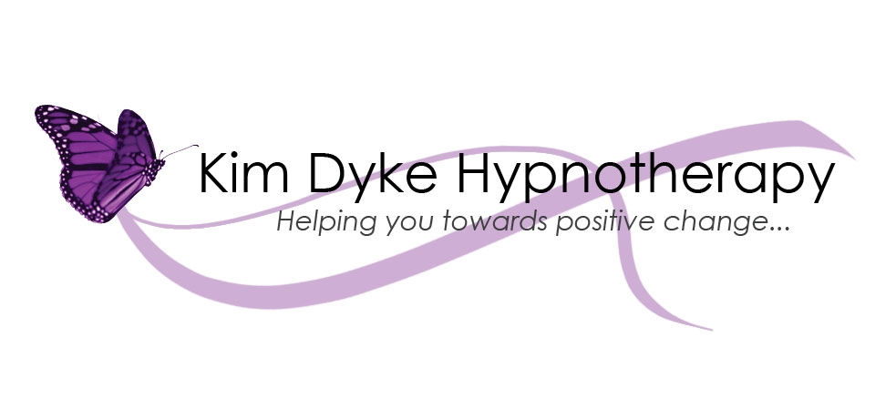

Terms and Conditions:

Commitment : Hypnotherapy is not a replacement for medical treatment, psychological or psychiatric services. I do not diagnose any condition. Hypnotherapy relies on the commitment and motivation from both the therapist and the client to get the best results. As the client, when you agree to undertake a course of sessions, you also agree to engage fully with the process, including completing any homework tasks and listening to the RelaxationTrack on a nightly basis as you settle down to sleep. It is with commitment and partnership working that you will see the best results.

Therapy Sessions and Fees : Each standard session lasts between 50 – 60 minutes and the agreed fee per session is as stated on my website www.kimdykehypnotherapy.co.uk. Fees are payable strictly prior to your appointment by BACS transfer.

Appointments & Cancellation Policy : You commit to attend the appointments that we make as your attendance at the appointment is part of your commitment to your ongoing progress. I require 48 hours notice for cancellation of a session or to rearrange an appointment either by telephone, text, email or through my website www.kimdykehypnotherapy.co.uk. Should this notice not be received, the full session fee will apply as you may have affected someone else taking that appointment in your place due to insufficient notice. If you are running late, please let me know as soon as possible and I will do my best to make a full session available. This often depends on appointments subsequent to yours and so cannot be guaranteed. If your session needs to be curtailed due to your late arrival, the session fee remains payable in full.

Confidentiality : In order to ensure continued best practice, I receive regular clinical supervision of my work with clients. During supervision it may be necessary to review your progress but any reference that could allow you to be identified is removed. Everything you say to me will be treated in the strictest confidence, except where disclosure is required by law without your express consent. This same confidentiality is respected when working with minors under the age of eighteen.

Standards of Behaviour : I undertake to treat you with respect and not to abuse the trust you put in me. I will use best practice at all times in our mutual interest. You agree not to come to sessions under the influence of alcohol or recreational drugs, except those medications prescribed by your doctor. If you do arrive at a session under the influence of alcohol or recreational drugs or demonstrate violent/abusive behaviour, I reserve the right to cancel the session and refuse any further therapy sessions.

________________________________________ ____________________
Signature of Client Date

General Data Protection Regulations 2018 (GDPR)

The full Policies and Procedures document can be found on my website www.kimdykehypnotherapy.co.uk

Frequently Asked Questions and Terms and Conditions of Receiving Treatment

What is the General Data Protection Regulations, 2018 (GDPR) and how does it affect me?

The GDPR replaces the 1998 Data Protection Act to ensure your personal and sensitive, confidential data is kept private and held securely, being processed in the way that you have agreed to. It is there to protect your rights as a consumer of a service or product that might involve your identifiable data, e.g. your name and address or whether you have a specific condition. It also covers any session records, text messages or emails we exchange. For more information your can read the Policy and Procedures document accessible via your Initial Consultation pack or via my website at www.kimdykehypnotherapy.co.uk.

How long will you hold my information for?

I am regulated by the CNHC, an organisation that stipulates I must hold your data for 8 years after your final session, unless you are a child; in which case I must hold your data until your 25th birthday, unless you are 17 when treatment ends, and then I must keep it until your 26th birthday. Therefore, all records will be deleted in the January after the above retention scales. This is in line with NHS regulations for holding data.

What if I don’t want my records to be held for that long?

Under the GDPR you can make a request in writing to me for all your records to be deleted. In this case all your paper records would be shredded with a cross shredding machine and any electronic data, such as emails or text messages, would be permanently deleted from the devices they are stored on. I would have to save the request for deletion you made but would not save any other data. In some circumstances my insurance company’s legal team may want to verify information I send out.

Why do you need to record this information?

I collect information about why you are using the service, a small amount of medical information and a small amount of information about your important others, alongside brief session notes. This information enables me to provide a high quality service to you, ensuring I am equipped with the knowledge of our previous discussions prior to each session. Your contact details / address and Doctor’s details will only be used with your explicit consent (see consent form below).

What lengths are made to ensure my information is held securely?

Hardcopy documents – Are all stored in a locked cabinet in a locked room.
Text messages – My work phone is secured with a pin code.
Emails – My email account requires a user name and password.
Email attachments – Any attachments sent by email to you containing your personal information would be password protected and the password would be sent to you via text message.
Electronic documents – Any electronic documents e.g. a letter to your Doctor, or an invoice, are password protected and stored on a password protected computer if they contain personal or sensitive information.

General Data Protection Regulations 2018 (GDPR)

The full Policies and Procedures document can be found on my website www.kimdykehypnotherapy.co.uk

Frequently Asked Questions and Terms and Conditions of Receiving Treatment

Is what we discuss kept confidential?

Everything we talk about during our sessions are strictly confidential between you and me. To ensure I am doing my job effectively and that I have the right support, I may discuss elements of our sessions with a peer Supervisor. During these discussions I do not disclose any details that may identify you to my peer Supervisor, and my peer Supervisor also adheres to the GDPR.

What if I see you outside of the session?

If we see each other outside of a session I will smile but will not engage in any conversation to ensure your confidentiality. You are welcome to share with other people about the therapy you are receiving, but I am obligated by GDPR law to ensure your confidentiality is protected. I would request that in order to ensure the success of your treatment, you refrain from discussing your treatment with me outside of your sessions.

What about other Health and Social Care Professionals?

As I adhere to the GDPR, any contact relating to you with other health care professionals would only be made with your signed consent. E.g. If I were to write to your GP to notify them of your treatment with me, and then notify them of the treatment ending, I would only do this if you were to sign the specific consent for this at the end of this document.

Exceptions:
In order to safeguard you and the people around you, if you were to disclose that you were going to carry out harm to yourself or someone else, then under my “Duty of Care” I am obligated by law to inform the relevant authorities. This is to support you to live well, and I would always aim to discuss this with you prior to contacting anyone.

If I was issued with a Police Warrant or Court Order for your information, by law, I would also have to provide them with your information.

General Data Protection Regulations 2018 (GDPR)

The full Policies and Procedures document can be found on my website www.kimdykehypnotherapy.co.uk

Frequently Asked Questions and Terms and Conditions of Receiving Treatment

Please Read This Document Carefully
The Frequently Asked Questions and related answers in this document establish the Terms and Conditions for Treatment at Kim Dyke Hypnotherapy.
Please ensure that these Terms and Conditions are fully accepted by you prior to attending subsequent appointments. If you feel you would require a change to your terms and conditions, please speak with me prior to our second session.

Signed Consent (in line with the new General Data Protection Regulations (2018))
As the processing of your personal data is required to enable me to provide you with a service, I do not require consent from you to hold your information securely or to provide you with this service, but will take this opportunity to assure you I adhere to all laws and procedures relating to Data Protection (Article 9,paragraph 2, (h) of the GDPR) and will only use your data to provide you with this service and for any further reason you explicitly consent to below.
I, the client, consent to you contacting my GP (if considered necessary), to inform them of the treatment I am receiving and why, and to update them (if considered necessary), when my treatment has ceased. This will also provide your GP with an opportunity to get in touch should this treatment not be suitable for you.

Signed…………………………………………………………………………Date……………………………………………

Please tick and sign below to confirm you consent to contact from Kim Dyke Hypnotherapy for the purpose of;
Appointment rearrangements ☐ homework or discussion synopsis ☐
evaluation of service ☐ newsletters ☐ promotional offers ☐
Please tick to confirm what formats you agree for Kim Dyke Hypnotherapy to contact you with:
Text ☐ Phone call ☐ Email ☐

General Data Protection Regulations 2018 (GDPR)

The full Policies and Procedures document can be found on my website www.kimdykehypnotherapy.co.uk

Frequently Asked Questions and Terms and Conditions of Receiving Treatment

Your privacy and confidentiality are important, and Kim Dyke Hypnotherapy will never use your information for any purpose other than that to which you have explicitly consented to above. You may withdraw consent at any time by getting in touch via 07825 957013, kimdykehypnotherapy@hotmail.co.uk or www.kimdykehypnotherapy.co.uk.

I have discussed and been provided with access to the GDPR Policies and Procedures for Kim Dyke Hypnotherapy.

Signed…………………………………………………………………………Date……………………………………………

